USER STORY: This is done by project manager or BA team in office:

- 1st we need to give the requirement which we collected from the client this is developed by BA team in the office
- Req: As a user I want to login to ecommerce application so that user can access all the features from the application
- Prompt:

Create a user story for the following requirement:

Requirement: As a user I want to log in to the e-commerce application so that user can access all the features from the application.

Create a user story for the following requirement:

Requirement: As a user, I want to register for the "https://demo.nopcommerce.com/register?returnUrl=%2F" application so that the user can access all the features from the application.

I want like this: split this into multiple user stories
User Story 1:
Title:
User Story:
Acceptance Criteria:

Note: if you can give me multiple user stories

TEST CASE DEVELOPMENT: (TESTER JOB)

PROMPT: Create a test case for the above user story. I want it in table format. 1. Test Scenario ID: 2. Test Case ID: 3. Test case Description: 4. Pre-Condition: 5. Test Steps: 6. Input Field: 7. Input Value 8. Expected Result: 9. Actual Result: 10. Status (Pass/Fail): 11. Severity: 12. Priority: 13. Comments

User Story 1: Login
Title: User Login with Email and Password
User Story:
As a user,
I want to log in using my email and password,
so that I can access my account and application features.
Acceptance Criteria
- User should be able to navigate to login page.
- Email and password fields should be displayed.
- User should be able to enter valid credentials.
- User should be redirected to homepage after successful login.
- Error message should appear for invalid credentials.

SYNTAX ERROR AND CORRECTION (this error will come when we miss “ ; () like this syntax)

Prompt: Find the syntax error in the code and correct the code

LOGICAL ERROR AND CORRECTION (this error will come when program correct but exp op not come)
Prompt: Find the logical error in the code and correct the code

TEST AUTOMATION SCRIPT WRITING

Prompt: Write automation test script using selenium with java and test NG for the following test case

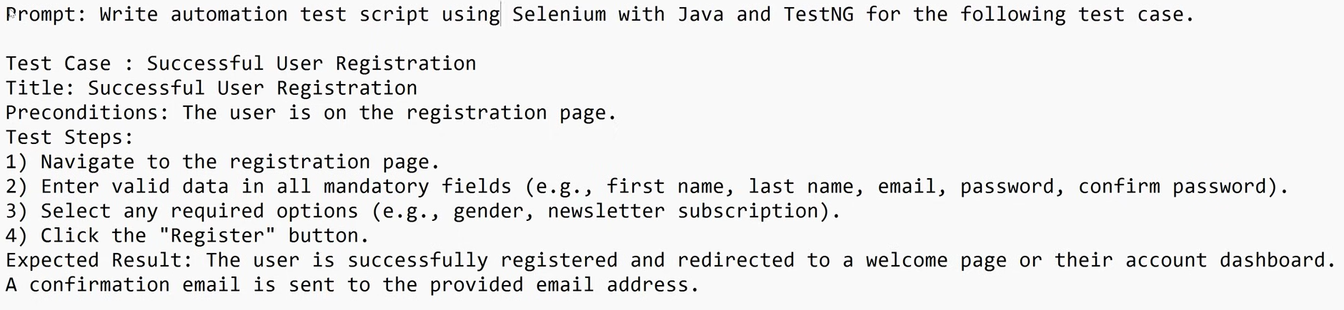

XPATH LOCATOR CREATION

Prompt: Write selenium XPath locator for all the elements in the page “https://demo.nopcommerce.com/”

PAGE OBJECT MODEL (POM) CLASS CREATION

Prompt 1: I have a web page “https://demo.nopcommerce.com/login?returnUrl=%2F”. Create login page object class for selenium java automation framework without Page Factory

Prompt 2: I have a web page “https://demo.nopcommerce.com/login?returnUrl=%2F”. Create login page object class for selenium java automation framework with Page Factory

